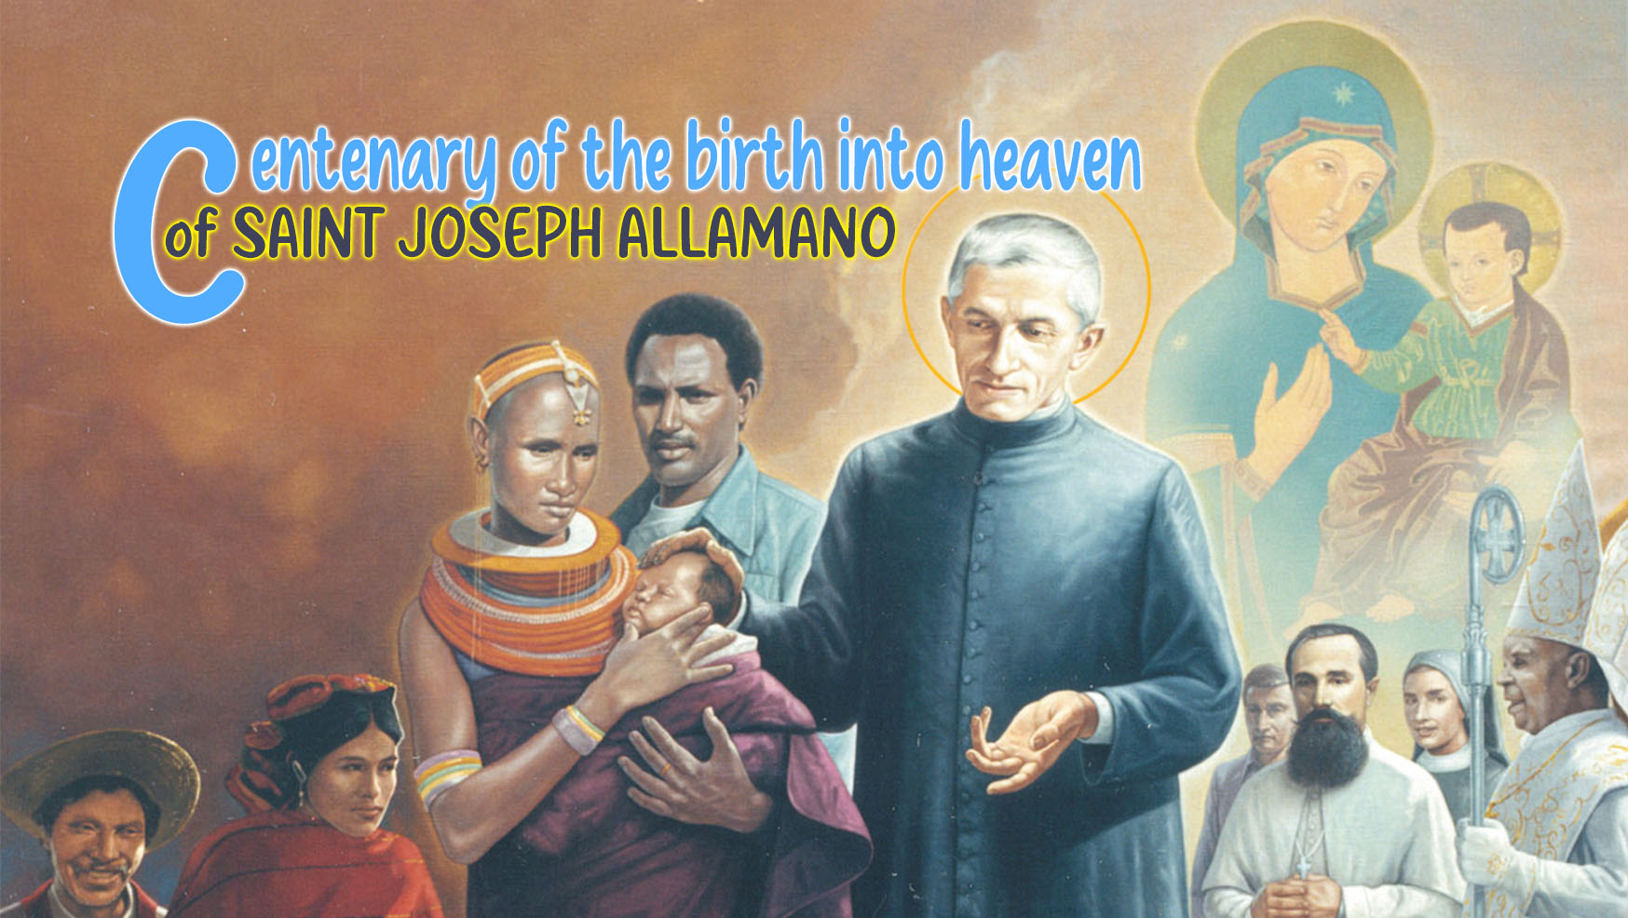

4

THE CONSOLATA, A LIVING PRESENCE ON OUR PATH TO HOLINESS

Mary with the Community awaits the gift of the Holy Spirit
"You will receive the power of the Holy Spirit which will come upon you, and then you will be my witnesses not only in Jerusalem but throughout Judaea and Samaria, and indeed to earth's remotest end." (Acts 1:8) The gift of the Holy Spirit promised by Jesus is poured out on the community that has encountered the Risen One and now makes it a witness, a missionary of the joy of the Gospel, in Judaea, Samaria and in all the ends of the earth. "After the resurrection, it is up to them to carry on this mission, to cast their nets again and again, to bring the hope of the Gospel into the “waters” of the world, to sail the seas of life so that all may experience God’s embrace. " A mission entrusted to the Church and to us today, at this juncture of history, with an infinite need to hear the Word that saves and revives hope.
Mary, the Mother, was there, amid the community, gathered in prayer and waiting for the Spirit (cf. Acts 1:14). She who knows well his strength and his action from when, at the Annunciation, he enveloped her in His shadow and made her Mother (Lk 1:35). "Between her and the Holy Spirit there is a unique and eternally indestructible bond which is the very person of Christ, 'conceived by the power of the Holy Spirit and born of the Virgin Mary'". She, the woman of the YES to God, with unshakable fidelity and trust, renews her Fiat, always, in every circumstance, in happy and sad events, when God's plan appears clear and when it is less comprehensible and she can do nothing but keep it in her heart, when her step becomes light and leads her quickly to meet the other and when she remains firm, nailed to the cross of her Son, in the deepest and most excruciating pain and finds herself still asked to become Mother, a womb that generates a new humanity that is born from the pierced heart of Jesus. It is the hour of the Son and there the Mother is present. Her life was a perennial YES to God's will for her.

The Consolata leads us to Jesus
St. Joseph Allamano said that "before being Consoled (Consolata), Mary had been the Sorrowful". She lived the passion and death in profound communion with Jesus and in the mystery of the Resurrection she was fully Consoled. Consolation is a gift of the Spirit, the Comforter, continually present in the heart of Mary, the true dwelling place of God. We understand why Mary, the Consolata, who knows God and knows God's ways, is our sure guide on the path that leads to Him. Allamano said: "You must be saintly proud to be under the protection of the Consolata; to bear the name of Our Lady and this must push you to make yourselves what you must be. You must bear your name well and have a high devotion to Our Lady. All the Saints were devoted to Our Lady: it is a sign of predestination."
Let us listen to her voice, sweet and reassuring, which tells us again: "Do whatever He tells you" (Jn 2:5). She invites us not to be afraid, to open our hearts to God, to become fertile ground where God makes us capable of bearing abundant fruits of life. Women and men of God who live a process of transformation that makes us transparent witnesses of God's love, therefore, truly missionaries in all aspects. People no longer with our gaze turned downwards, centred on ourselves, in the narrow and confined spaces where an increasingly demanding "I" tries to lock us up. It is the Spirit who comes like an impetuous wind, in a new Pentecost, enters closed spaces, crosses the armoured doors and opens us to the light and warmth of the Love that saves. It makes us free people, capable of recognizing how God visits us today, visits our world shrouded in darkness, anguish and pain.
"How many times did Joseph Allamano turn his sight to the Consolata and how many times did he let himself be looked at by Her! We too want to contemplate her face and let ourselves be looked at by Her, here lies our strength."

The Consolata, our Most Tender Mother
The month of June this year is a particularly charged month full of grace, a gift from God. We are preparing to live Pentecost and to live the novena and feast of our mother, the Consolata, in this blessed and holy year of the Jubilee of Hope. God the Father, who loves us deeply and wants to gather humanity around Himself, who wants every son and daughter to live safely at home with Him, to know his heart and his great love for each one in particular, and is willing to reach us where we are, in the situation we live, where our path is leading, to make us know His heart and His infinite love, an unmistakable touch that makes us bounce up and follow Him on His path. Then we too will be sensitive and attentive in recognizing and fulfilling in our lives God's will for us, which is revealed through mediations that the Lord puts on our path. And on this journey, it is so sweet and so beautiful to have the Consolata, the most tender mother, next to us.
"Is not the Blessed Virgin under the beautiful title of Consolata our Mother, and we her children? … We are children of the Consolata, and most beloved children, but do we practically always show ourselves to be such, by invoking Her often, by honouring Her in as many ways as possible, and by having recourse to Her with the confidence of the most tender children? Let us also try to listen to her desires, which are that we make ourselves good and holy."

For personal reflection:
- How much do I care about the call to live evangelical radicalism? Do I feel that I am walking on the path of holiness? Or am I treading other paths?
- Who is the Consolata for me? Do I feel she is a Mother, beside me, a guide on my journey?
- How do I want to prepare my heart to celebrate her?

Pope Leo XIV, Homily for the Inauguration of the Petrine Ministry of the Bishop of Rome, 18 May 2025
Pope Francis, General Audience, 13 November 2024.
Testimony, Sr. Maria degli Angeli Vassallo.
Conf. MC, III, 275.
General Governments MC and IMC, The Founder and his Consolata, Nepi/Rome, 16 June 2024.
Conf. MC, I, 11.

