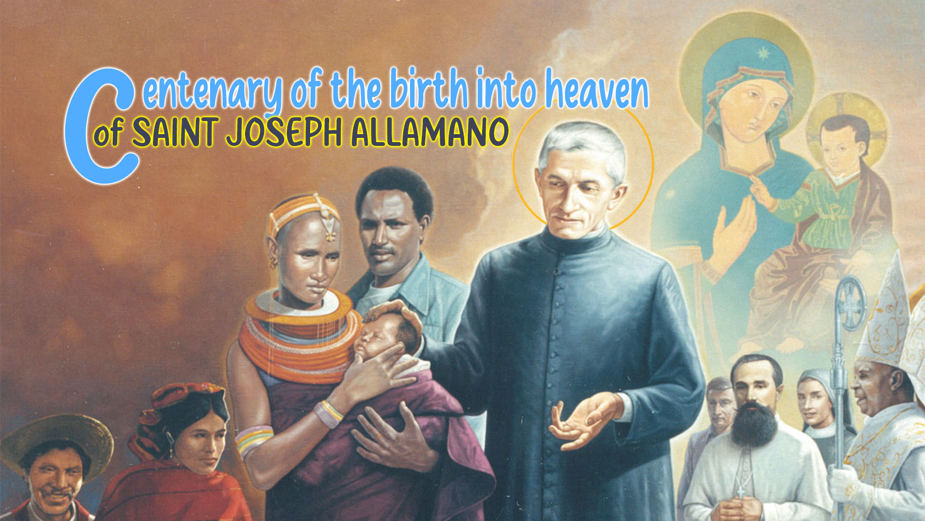

6

Holiness and God's Will

“In a remote African village, there was a leafy tree, with tall branches and green leaves. She was very proud to give shade to all the people and shelter to the birds. Everyone who passed by admired her. One day, a local inhabitant arrived with a saw and began to prune it. The tree was startled and cried out, “But why? I'm so strong, beautiful and full of leaves! Why do you cut me?” The man didn't answer... He just continued his work calmly and precisely, removing dry branches and even some green ones. The tree felt pain, sadness and misunderstanding. For weeks she felt diminished, empty and ugly. As she no longer received compliments, and the birds were gone, she thought: “It's that man's fault... destroyed my life!” The rainy season came, and with it a new life for the tree: new branches sprouted, stronger, more beautiful. The birds returned, the shade became larger, and the fruits began to grow, something that the tree had never had.
Then she understood: “The pruning of the silent man was the will he had for me... and it was for my good, because only by pruning could I bear fruit.”

How often, like this tree, do we not understand the “pruning” that life brings us: moments of pain, loss, humiliation or apparent failure. We find it difficult to perceive that, behind these situations, there is a greater love, which silently prepares something more beautiful and fruitful for us. This pruning we can call God's Will!

Pope Francis has often spoken to us about God's will, especially highlighting 4 fundamental aspects:
Discerning God's Will in concrete life: God's will is not something abstract or distant, since it manifests itself in the concrete situations of everyday life: “To discern is to seek to recognize God's will in the signs of the times and concreteness of life.”
God's Will is always Love and Mercy: God's will is never something that humiliates or destroys us: “God wants all men to be saved and to come to the knowledge of the truth.”
Abandoning oneself with trust like Jesus: Trusting and surrendering to God's will is an act of love and faith: “God's will is not a kind of blind destiny. It is a project of love for each one of us.”
God's Will and Christian Joy: when we accept God's will, we find peace and joy: “Doing God's will requires listening, prayer, and generosity. But this is what leads us to true happiness.”
One day, talking to the Consolata Missionary Sisters, St. Joseph Allamano concluded: “I tell you that my greatest consolation is that I have always done the will of God.” On another occasion, explaining to the students why he had dismissed a coadjutor who had not obeyed, he said: “But nothing falls without the will or permission of God... For this reason, I prayed in these Exercises that the Lord would give me not only conformity to his will, but uniformity, and I said: I do not want my will to be done here, but only the will of God.” Doing God's will was for Allamano the secret to becoming a saint, in order to meet God and to fully realize his missionary vocation. He was deeply convinced of this, to the point that he not only scrupulously tried to do it himself, but also constantly reminded others of it in his lectures.
It was from this concrete and persevering experience of God's will that St. Joseph Allamano came to understand and teach that on the spiritual path there are different stages in one’s total abandonment to the divine will. It is not only a matter of accepting with resignation what God permits, but of growing progressively in our union with him, until the human will itself conforms, unites and finally disappears within the sovereign will of God.
It is in this horizon that he proposes three distinct degrees, which despite having their origin in the ascetic and mystical theology of saints such as St. Alphonsus Mary de' Liguori, Allamano always promoted them with his missionaries:
Conformity consists in recognizing the divine will and adjusting our choices to it, even if our own will still remains distinct: “The first step to perfection is to conform one's will to the will of God; that is, to accept all that God wills and to reject that which God does not want.”
Uniformity is a deeper step: it means merging our will with God's will: “When we are united to God's will, our will and God's will become one, because we want nothing else but what God wills.”
Deiformity is the highest degree. It is when we completely erase our own will, merging it in such a way with the divine will that only the will of God remains: “The more perfectly we are united to the will of God, the holier will be our life. One who is thus united can say: 'Lord, do with me and with all that is mine what is pleasing to you.'“
To understand this path of surrender to the divine will, there is nothing better than to look at the example given to us by Jesus Christ, who always lived and testified to be in conformity with the will of the Father. St. Joseph Allamano, in his own words, helps us to deepen this desire for what God wants in the simplest way:
“The Lord said: Non mea voluntas, sed tua fiat. Not mine, but your will be done. So, there were two, and He conformed His will to the Father's. When he said that he did what his Eternal Father wanted and that it was not He who worked, but his Eternal Father, it was an intimate union that ceased his will and only the will of God remained. Both in his words and in his actions, he shows the three degrees of God's will: conformity, uniformity, deiformity. He said: “I put this will in my heart. It's my food”. Food is eaten, it enters the blood, it nourishes us, it becomes one thing. Thus, Our Lord's will was to do that of His Eternal Father. That's it, conforming is like food that turns into blood. The Lord also said, “I always do what pleases my Father”.
Trusting in God's will often means facing the mystery of silent pruning which, although painful, prepares in us new and more abundant fruits. Like the tree that, even wounded, is reborn with renewed vigor, we are called to welcome the “pruning” of life as expression of the merciful love of God, who always wants our good and our sanctification. In this way, we will live fully the mission entrusted to us, in the confidence that, even in difficulties, we only need to abandon ourselves to God's will, certain that He knows what He is doing.
For personal reflection
- How can we learn to welcome and discern the “pruning” or difficulties we face in our lives?
- With our eyes fixed on Jesus, what do we lack for a deeper surrender to the missionary project?
- How can we, in mission, witness to others that doing God's will brings true joy and fruits to personal, family and community life?

Pope Francis, Address to the Synod, 3 October 2018.
Pope Francis, Evangelii Gaudium, 44.
Pope Francis, General Audience, 20 March 2019.
Pope Francis, Gaudete et Exsultate, 23.
Giuseppe Allamano, Pensieri e Esortazioni, Turin, 1968, p. 241.
Giuseppe Allamano, Conferenze alle Missionarie della Consolata, 1925-1926.
Afonso Maria De Liguori, Uniformity with the Will of God, 2006, p. 18.
Afonso Maria De Liguori, Uniformity with the Will of God, 2006, p. 25.
Afonso Maria De Liguori, Uniformity with the Will of God, 2006, p. 25.
Giuseppe Allamano, Conferenze alle Missionarie della Consolata, 10 November 1918, XIV. 11.

