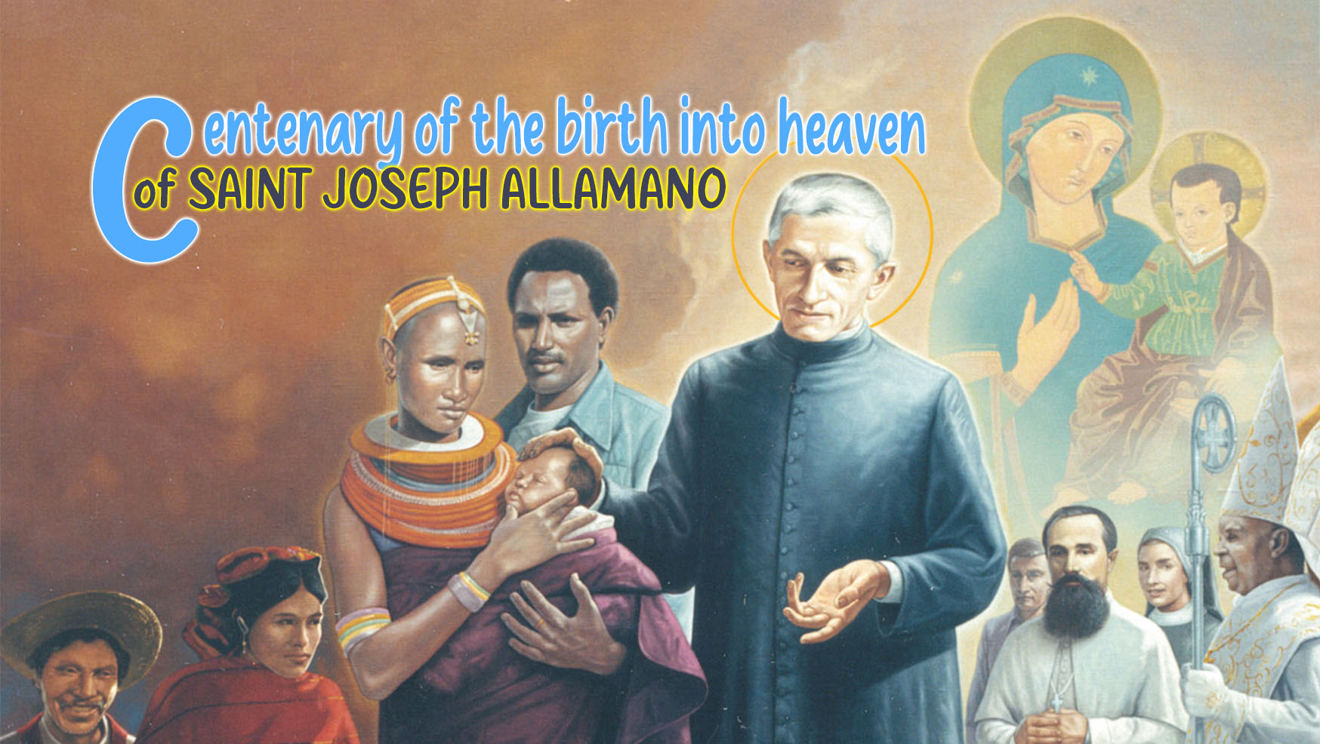

7

HOLINESS AND THE CROSS

"The cross is our book" (G. Allamano)
"All the more so as missionaries," said St. Joseph Allamano, "we must know how to enter into the mystery of the cross." In a certain way, we must be 'experts' in its mystery of salvation and in the suffering of the poor. This reflection on the cross is not an easy one: it was not so for the apostles who did not understand its meaning, it was not always so for St. Paul, although he went so far as to say: "Let there be no glory for me except in the cross of the Lord" (Gal 6:14), nor is it for us today. Yet, this reflection offers us the true key to understanding what our consecrated and missionary vocation is, and how to live it.
How can I immerse myself in the lives of the people, in the tangle of suffering that accompanies so many peoples in today's world, and become a voice of hope and consolation, a proclamation of salvation, without following the same path that Jesus travelled? How can I celebrate the Eucharist every day, the Sacrifice of Christ, and break the consecrated bread without remembering that Jesus' words are first and foremost addressed to me: be you bread broken for your brothers and sisters, blood poured out that joins me for the salvation of the world... "Do this in memory of me"!
Speaking of the new evangelization, Pope Francis reminded us of the context in which we live and work, and of our duty to "study the signs of the times." He stated: "However, we cannot forget that most men and women of our time live in daily precariousness, with disastrous consequences. Some pathologies are increasing. Fear and despair take hold of the hearts of many people, even in the so-called rich countries. The joy of living is frequently extinguished, disrespect and violence grow, inequity becomes increasingly evident." What way must we follow to enter this world of suffering and be bearers of "good news"? How can we become, in Jesus' way, "experts in suffering"?

"My God, my God, why have you forsaken me" (Mt 27:46)
These words are the beginning of Psalm 21(22), but they are above all the expression used by Jesus in the moment of the most atrocious pain, hanging on the cross. They were words of infinite suffering, as if he were saying: "Father, why do you leave me alone in this painful situation and do not intervene, am I not your Son? Jesus shed his blood; he gave his life into the hands of his enemies. What was left for him to give? The emptying (kénosis) of even his own "divine life".
Behind the facts of the passion described in the Gospel, there is a story of love between the Son and the Father, which culminates in this act of abandonment. The Founder uses a bold phrase from St. Francis de Sales: "Calvary is the theatre of lovers." His suffering is no longer pain, but love and intimate union with his Father. The Father, seeing Jesus obedient to the point of being ready to regenerate his children, to give them a new creation, sees him so similar to himself, as if he were "another Father and Creator". At that moment, Jesus is all 'God' because he is pure love. At the same time, he is closer than ever to sinful man and to man divided and distant from God. He experiences pain, the greatest pain, both physical and spiritual.

Our suffering, our kenosis
In his suffering, Jesus becomes a figure of every human pain, of every rupture and division, of every illness and of those pains that close us in on ourselves such as darkness, aridity, failure, loneliness. Jesus therefore shows us that the true dynamism of love, in which man finds that the fulfilment of his personal being is always crossed by a moment of death, of self-giving, of losing his own life. A moment, that is, of kenosis-emptying.
Every true love that creates life brings with it this moment of not being, which is a prelude to a new fullness of being. There is no pain and suffering that cannot make us enter into this divine logic. Jesus came to give a name to every human pain, so that every pain, every cross is no longer "something", but "Someone". Every pain of ours and that of others hides a face of Jesus crucified. It is therefore necessary to know how to discover it and call it by its name. Pain is "a sacred thing"!
Jesus told us: "As I have loved, you also must love one another". As in a divine alchemy, the crucified Jesus is able to change all our pain into love, into communion. We need to recognize his face in every pain, to welcome it, to forget our pain and to begin to love the other.

"The crucifix is the book to read every day" (Allamano)
The Crucified One is the model for those who must carry out mission and unite the human family ("when I am lifted up from the earth, I will draw all men to myself" Jn 12:32). In fact, unity with the other is not possible without "I" emptying myself of myself. The only thing that has to stay in me is love. In other words, I must know how to die with Jesus, to lose everything. For mutual love to exist, I must be ready to lose everything: my ideas, my projects, my inspirations, even the most evangelical ones. I always have to put the other person before myself. This is possible only if I become 'empty' for the love of the other.
Jesus crucified is the teacher who leads to maturity. In the life of people and of the community there are two things that really make us mature: love and pain. A mature person is that person who opens himself in a self-giving way to the other, who knows how to love by giving himself totally. Only mature people build communion. In the Crucified One, in fact, we see these two realities brought to the most perfect realization. It is for this reason that Allamano loved to give each departing missionary the crucifix!

Jesus Crucified gives us a heart of solidarity and mission
We missionaries are called to be apostles, to make our lives a gift to others, to give preference in our love to the most needy. It is not enough for us to state this in words: this apostolic yearning must be born from the depths of our hearts. The choice of the poor, the last, the marginalized; sharing in the great sorrows of the Church; the social divisions and the great fractures that are cracking the modern human family. We must be able to take everything on ourselves, to be poor in ourselves and burdened with the poverty of others. We truly learn to "evangelize" only when we open ourselves to others, and take upon our shoulders their pain, their suffering, their cross together with ours.

For personal reflection
- Following Jesus: Mt 10:34-39; Lk 14:25-33;
- Sorrowful face: Novo millennio ineunte, 25;
- The Law of Love: Evangelii Gaudium, 101, 86.
- This I want you to be, n. 136-138.
- In my personal pain, do I find the strength to open up to the other?
- Does the pain of others cause anger in me, or does it manage to make me grow in love?
- In missionary work, do I often know how to leaf through this "book" which is the crucifix, my true "traveling companion"? Let me enumerate some moments or instances in which I realize this...

cf. This I want you to be n. 136
Evangeli Gaudium 52
IMC Conferences I, 461

