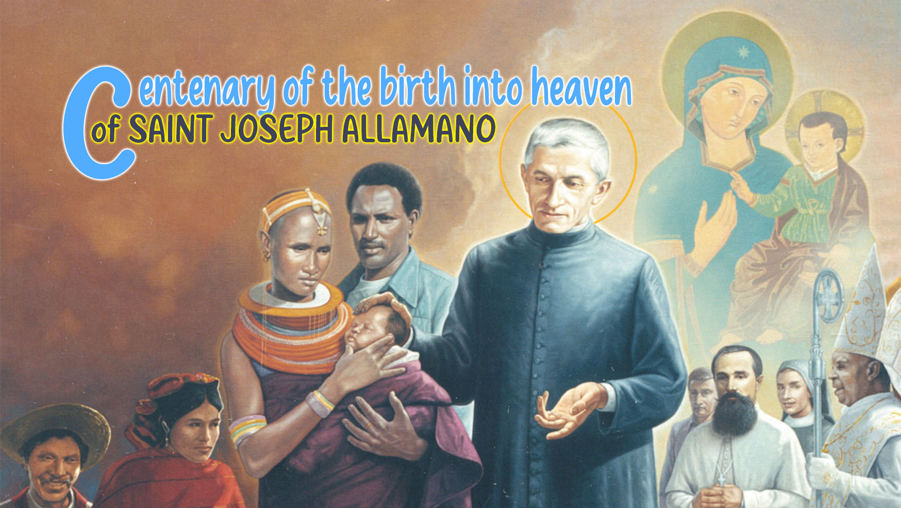

8

HOLINESS AND THE “SOMETHING MORE”
OF ST. JOSEPH ALLAMANO

On February 17, 1926, the Turin newspaper Il Momento wrote: “The life of Canon Allamano is not counted using the calendar, but in his spiritual intensity, in his superior spirit, in the straightforwardness of his character, in the reflection of a good accomplished and silently stratified in the shadow of his beloved Shrine. He was not the man of ostentation. He was not the eloquent man. He was the man of industrious silence.”
The search for quality of life, the effort to do well the good and thus be “extraordinary in the ordinary”, the “active silence”, the energy and enthusiasm, were always the characteristic aspects of his style of holiness which, speaking to his missionaries, he then qualified as “our holiness”. He discovered this “style” by approaching in particular the life and teaching of his holy uncle, Joseph Cafasso. He wanted to make it his own, not only because it was congenial to his personality, but because it was carefully studied, researched and cultivated. He imbued it with Christian virtues and strong evangelical references to the point of making it characteristic of his whole life and priestly ministry.
This is how he explained to aspiring missionaries the phrase of Mk 7:37 'He did all things well': “These three words [bene omnia fecit] deserve to be written on the walls of our houses and they should be able to be written on the tombstone at our death: he has done all things well”. And he explained how some people always look for great, extraordinary things, while God is present both in great things and in small things so we must be careful to always do everything well. Saints are saints not because they performed miracles, but because they did everything well.
The Founder felt he was asking the members of the Institute for “something more” and a higher quality of life, precisely by virtue of their specific missionary vocation. For example, on August 19, 1917, speaking to the Consolata Missionary Sisters, he said: “Love our neighbour more than ourselves. For a missionary there must be something more.” On November 16, 1916, speaking to the missionaries about holiness, he asked himself: “And what should this holiness be? greater than that of simple Christians, higher than that of simple religious, distinct from that of secular priests. The holiness of missionaries must be special, even heroic and, at the opportunity, extraordinary so as to work miracles. Continuing the mission of the Apostles, they must be able to apply to themselves the words and deeds of Our Lord Jesus Christ.”
Illustrating the individual virtues necessary for the missionary, our Saint loved to emphasize the value of each one and qualify it as the most important. What interested him was to accentuate their importance. An overall look at his teaching, on the need to become saints, allows us to grasp two complementary attitudes of this “more” in which the missionary must be equipped.

1. Quality
Starting from the observation that a spiritual “normality” lowers the tone of our life and the effectiveness of our evangelization, the IX IMC General Chapter envisaged quality of life as the objective towards which to aim decisively: “We believe that, in the light of the life and teaching of our Father Founder and the demands of the mission, quality is an essential requirement to be always kept in mind at all stages of the life of the missionary” (p. 41).
Allamano called this search for quality of life “our holiness”. He inculcated it in us Consolata missionaries until it became our “physiognomy”. It must begin first of all with the careful and scrupulous search for all the means that help us to walk decisively towards holiness, fulfilling all our duties well. It must then influence apostolic zeal, always keeping alive the “inner fire”.
Fire, apostolic zeal, ardour, spending oneself wholly for others, were typical expressions of Allamano to describe the indispensable attitude of every missionary. For him, fire signified the love that must burn within us and which he identified with the Pauline expression “Charitas Christi urget nos” [the love of Christ impels us] (2 Cor. 5:14). Everything springs from love: “You must have so much charity that you give your very life. We Missionaries are devoted to giving our lives for the salvation of souls. Loving our neighbour more than ourselves must be the missionary's life program.” Without this love there would be no reality, no substance of the apostolic man, and all our reflections would be pure academic thought and the resolutions envisaged would remain a dead letter.

2. Fidelity and the “nunc coepi”
A precaution that our Saint still advised his missionaries in order to cultivate their vocation was to live intensely and well every day and every moment the “nunc coepi” [now I begin again]. In fact, the time of our existence unfolds moment after moment, day after day. The past is no more, the future is not there yet, only the present remains for me to realize my existence: I must live it well, giving meaning to everything I do, certain that in this way I fulfil God's will and fulfil my vocation. He then suggested to his Missionaries fidelity in small things to ensure fidelity in the most important choices. Scrolling through the Spiritual Life, we immediately realize how important this conviction was for him. Here are some of his expressions, gleaned in his conferences, which find their common root in “fidelity”:
- The members of our Institute must bring about their sanctification with fidelity to the little things. May God make you understand this lesson well and encourage you with his grace!
- Fidelity to the rules even the smallest; therefore, observe them all, in everything, down to the smallest detail. Every little rule has an inherent grace of God.
- Fidelity to the practices of piety done in common, since in prayer in common there is more blessing from God.
- Fidelity to carry out particular duties: and to follow them with commitment and detachment; not to seek, as the opportunity so easily presents itself, one's own convenience.
- Fidelity to the good use of time: occupying it entirely and intensely; employing all our power, our will and our attitude there.

For personal reflection
- How and where do I strive to express the “something more” of the Allamano in my life?
- Do I live the “more” by looking for the quality of my actions or for the accumulation of them?
- Do I find that the “nunc coepi” qualifies the actions of my days?

I. Tubaldo, Giuseppe Allamano, I, p. 692
This I want you to be, n. 5
MC Conferences, II, p. 124
IMC Conferences, II, p. 81.
IMC, Acts of the IX General Chapter, p. 41.
Spiritual Life, 461.

