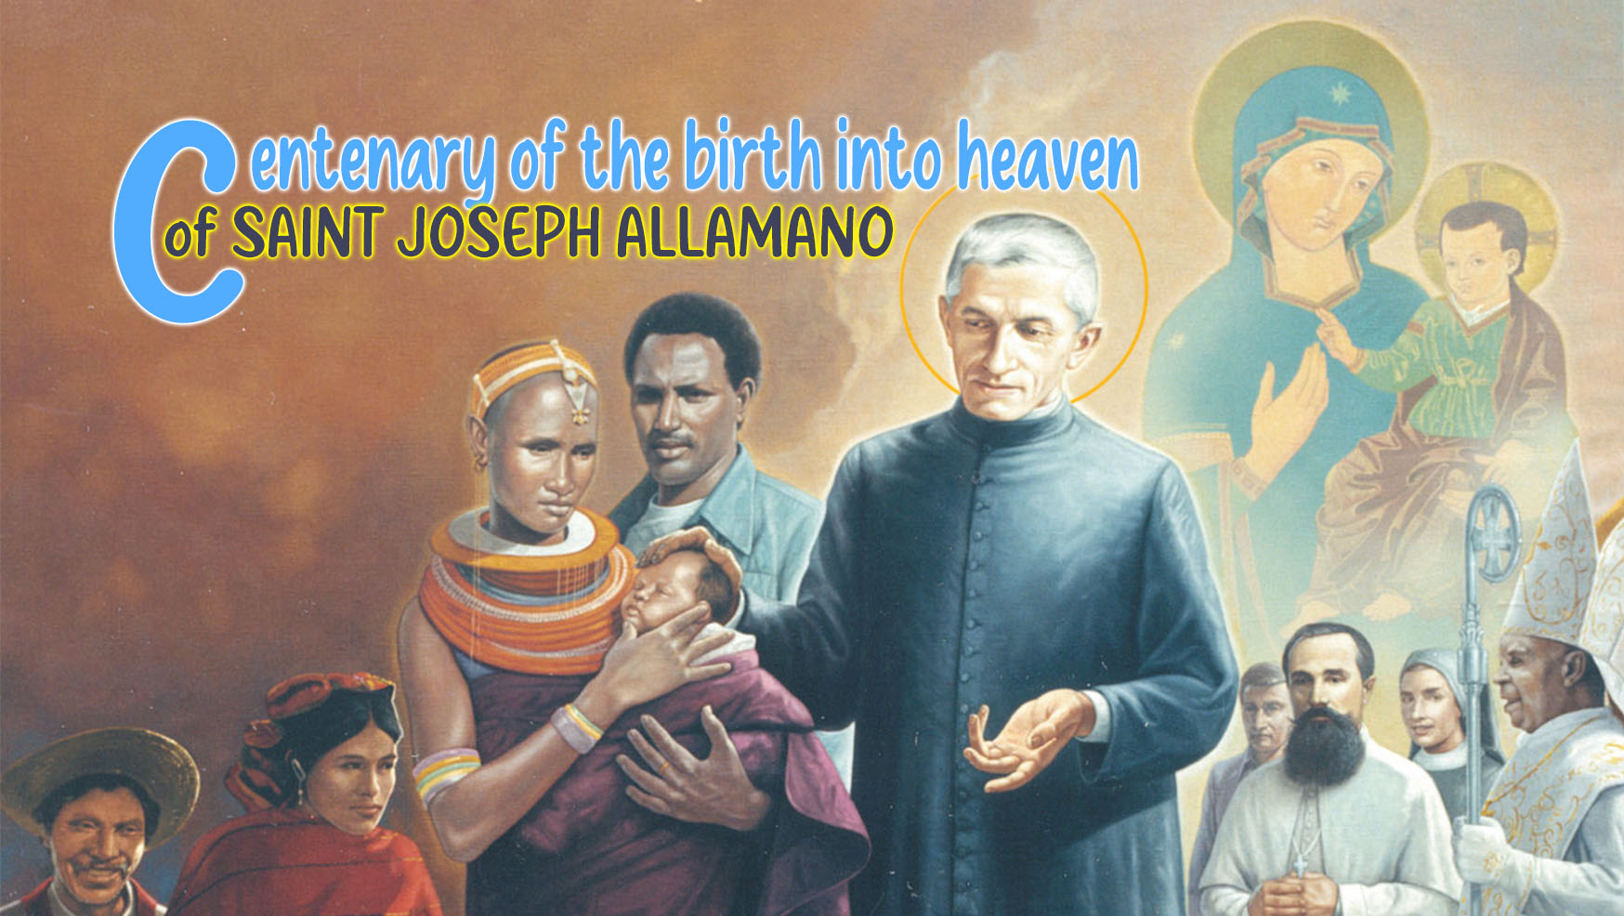

9

HOLINESS IN DAILY LIFE

We have just celebrated the first anniversary of the canonization of St. Joseph Allamano on October 20. It was a moment of celebration but also as a time of grace that reaches all of us who let his life and spirituality inspire our lives, our choices, our actions, our relationships. In fact, the holiness lived and proposed by St. Joseph Allamano, master of the spiritual life, is an expression not only of a person who knows the depths of the human heart, accustomed as he was to listening to what moves within himself and in others, but above all of one who knows the ways of God, committed from a young age to following Him with fidelity and love, putting Him at the center of his life with the firm purpose of fulfilling His will.

Extraordinary in ordinary things
Joseph Allamano had a deep love for God and for the person, near and far, for those he has before him as their spiritual guide, formator, confessor, sons and daughters to whom to transmit a charism and for those who were far from him, geographically and otherwise, those who lived in the borders where God's love had not yet been proclaimed. His gaze went far beyond the world he knew.
An expert connoisseur of God's ways, he knew how to recognize and encounter Him in everyday life, in the present moment and not only in the great and extraordinary events that happen sporadically. The holiness that Joseph Allamano proposes is made up of small gestures, in the concreteness of every day, in being "extraordinary in the ordinary". The call to holiness is a call made to everyone and possible to everyone. Everyday life is not a repetition of actions or ways of doing things, a day similar to the next, perhaps lived with a certain boredom and lack of interest. Everyday life is the privileged moment and place, the here and now, where God's grace reaches us, where we meet God who continually seeks us and invites us to a communion of love, and this makes our days full of opportunities to love God and our brothers and sisters, near and far, without exception. This is the way of holiness that Allamano proposes: "One does not often have the opportunity to do extraordinary things, instead the ordinary ones happen every day and all day long.... Not extraordinary things, but being extraordinary in the ordinary."
Pope Francis expresses it well in the Apostolic Exhortation Gaudete et Exsultate: "It is only a matter of finding a more perfect way of living what we already do: 'There are inspirations that tend only to an extraordinary perfection of the ordinary exercises of Christian life'. When Cardinal Francis Xavier Nguyên Van Thuân was in prison, he gave up consuming himself while waiting for his release. His choice was: "I shall live the present moment, filling it with love"; And the way in which this was done was: "I seize the opportunities that present themselves every day, to perform ordinary actions in an extraordinary way."

"I'll do everything well"
Joseph Allamano lives daily life as an opportunity to do good well: "Let us imitate Our Lord. Let us do our duty for a good end, and then we can say that we do everything well. Bene omnia facio, I will do everything well. The secret of becoming saints is not to do big things, miracles, etc., but to do things well." "Good is to be done well and without noise" is typical of his way of being and doing, as it was for his uncle St. Joseph Cafasso, and he repeats it insistently to his sons and daughters. To do good always and without noise, motivated by the love of God and not by personal pursuits, avoiding the risk of selfishly putting ourselves at the center of attention but doing everything for the Lord, and only for the Lord. "I have the idea of Cafasso, that good must be done well and not noisily. To do good promptly, exactly, with good will. It is not enough to say the rosary, it must be said well. If we study, we study well. If we work, we work well and do well all the actions of the day."

I begin
Allamano, however, was well aware of the struggles that we fight daily within ourselves due to our own fragility. He knew that there can be and there are falls and regressions that tend to discourage us on the path of goodness and from this comes his insistence on always starting again, continuously, "nunc coepi", knowing how to get up. "If we think: in a month, how many blessings! Nunc coepi [now I begin] we must say if we see that we have behaved wrongly. St. Teresa owes her sanctification to the continuous saying: I begin...". "Forty or fifty times a day; she asked the Lord for forgiveness and exclaimed: "This is grass in my garden, it is not well cultivated!"

Sowing goodness
The situations of great suffering and upheaval that the world is experiencing today, the urgency for peace that rises from the depths of the hearts of entire populations at the risk of their lives, are urgent invitations and calls to put the good into circulation. To be people who allow themselves to be reached by God’s grace, on a journey of growth and transformation and to transmit small concrete, daily gestures of goodness, benevolence, reconciliation, peace. Living the Gospel in a radical way is possible for everyone according to the intuition and life of Joseph Allamano.

For personal reflection
- What does it mean to me that the holiness of Joseph Allamano has been recognized by the Church? How does his life inspire my life and mission?
- How intensely do I live my daily life? Do I recognize it as a time that the Lord gives me to live to the full?
- What contribution do I make to today's world? Are my daily choices a quest to do good done well and with love?

This I want you to be, n. 5.
Gaudete et Exsultate, 17.
MC Conferences, I, p. 421.
This I want you to be, n. 5.
MC Conferences, I, p. 67.
This I want you to be, n. 196.

