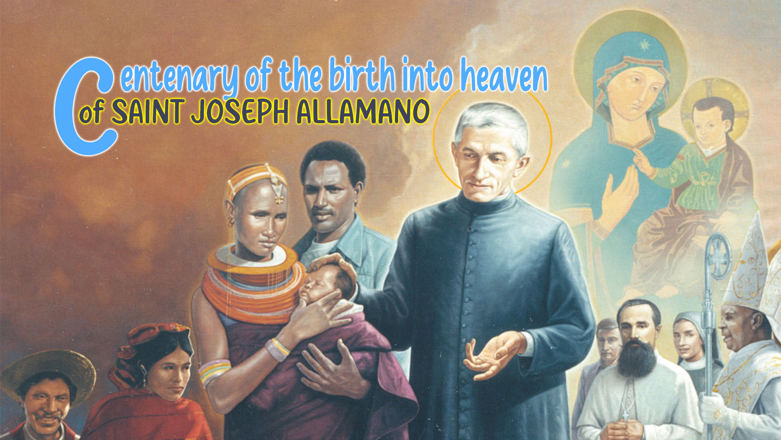

10

HOLINESS AND
THE FAMILY SPIRIT

“Once upon a time there was a small village hidden in the mountains, where every house had its own garden. The inhabitants were very proud of their flowers, all beautiful, but different: some gave off strong scents, others showed bright colours and others grew silently, without attracting attention. As time went on, though, people started competing. Everyone wanted to show that their garden was the most beautiful. Some boasted about roses, others about lilies, and soon conversations turned into arguments. The wind stopped blowing in the village and the land began to dry up. Realizing what was happening, the village sage asked each one for a seed from his/her garden. He gathered them all in his bag and, in the central square, built a small garden where he planted the mixed seeds.
He called all his neighbours to him and, gathered in the square, said to them: “If everyone brings a little of his water and his care, this land will flourish again”. Some laughed, others doubted. But, little by little, one brought water, another a handful of good soil, another created some shade with a cloth... In a short time, the seeds sprouted from the ground and, in front of everyone’s eyes, a garden full of colourful and different flowers was born. The wind blew back into the village and the new garden, cared for by everyone, began to attract visitors from afar.”
This parable is a mirror of what happens when self-love grows more than common love. Each home had its own garden, just as each person has his or her own gifts, talents, and unique ways of serving. At first, harmony may reign; but when the focus is shifted from sharing into confrontation, the wind – symbol of the Spirit – stops blowing.
The wise man resembles St. Joseph Allamano when he gave life to the Missionary Institutes. He believed that the real garden flourishes when everyone offers what they have: a little water, a handful of soil, a simple gesture of care and love.
This is how the family spirit is born: when one leaves “mine” to embrace “ours”, when one understands that the beauty of the Mission does not lie in shining alone, but in flourishing together, sustained by the same Spirit and rooted in the same missionary ideal.
St. Joseph Allamano understood that the strength of the Mission is not only in individual zeal, but above all in communion. He said clearly: “The Institute is a family; you should live as true brothers. You are all brothers and sisters, and you must prepare to live together and then work together for life. We should have esprit de corps to the point of giving our lives for each other.” In his spirituality, fraternity is not a vague feeling, but a concrete way of living the Gospel. Community life is the first field of mission, because it is there that one learns to love, to listen, to serve and to forgive.
The family spirit is a gift and a task: it is born of the Holy Spirit, but it grows in the daily commitment to welcome, share and walk together. When we live together, our diversity becomes richness and mission becomes communion. Every simple gesture – a smile, a listening, an outstretched hand – is a seed sown in that great garden that is the Family of the Consolata: “Walk together, always united, and the Lord will bless all your works”.
Thus, the family spirit is not only an ideal to be admired, but a reality to be built day after day with humility, patience and joy. It is the way of living and proclaiming the Gospel that Allamano dreamed of: a mission made up of hearts that recognize each other as brothers and sisters and walk side by side.
The essential foundations for cultivating this family spirit proposed by St. Allamano are practices and attitudes that make sure the community is alive and missionary:
Fraternal charity - Charity is the first sign that God dwells among us and St. Allamano insisted that fraternity is shown in simple gestures of respect, forgiveness and mutual support: “We must love one another as true brothers and sisters; where there is charity, there is God.”
Unity and communion - Union is the most precious good of a community because without unity there is no mission that can last; with it everything flourishes: “Union is the first good that a religious community can have. Woe to those who destroy it!” “We must all form one heart and one soul.” This communion reflects the model of the first Christian communities, where mission was born of fraternity.
Simplicity and sincerity in relationships – St. Allamano wanted everyone to live in a simple, transparent and true environment, without masks or formalism: “Simplicity is the way to peace; Where there is simplicity, there is sincerity and trust”. To live in truth is to live with inner freedom: each one can be himself, with humility and trust.
Obedience and mutual respect - Family spirit includes respect for brothers, sisters and superiors, not out of obligation, but out of love. Obedience, for Allamano, must be born of faith and the desire to collaborate for the common good: “Obedience must be full of love, as in a good Christian family.” To obey and respect is to recognize in the other the presence of God who guides and sustains the community journey.
Participation and co-responsibility - Allamano insisted that everyone feel co-responsible for the life and mission of the Institute, sharing joys and difficulties: “Everyone does their part; all together we form one body for the glory of God”.
When everyone offers the best of themselves, the community becomes a living, strong and fruitful body.
Joy and good spirit - Joy is the fragrance of charity. For Allamano, good humour and a positive spirit were signs of a heart at peace with God and with the brothers: “Where there is joy, there is the Spirit of the Lord.” “Rejoice in the Lord; A happy heart is a heart that loves.” Community joy is a silent form of evangelization.
Devotion to the Consolata - At the centre of everything, St. Allamano placed Mary, the Consolata, Mother and model of the whole missionary family: “Have great devotion to the Consolata; She is our Mother, our Consolation.” The presence of the Consolata unites, consoles and inspires: it teaches us to live as brothers and sisters, keeping everything in our hearts and always trusting in God.
The family spirit, like the garden in the parable, is the fruit of many hands and of the same heart. Every seed we sow – a gesture of forgiveness, a smile, a cherishing word – becomes a visible sign of God’s love that dwells among us. When we live in this spirit, we cease to be just individuals united by an ideal and become a true missionary family, united by the Spirit and by the Consolata, Mother and model of communion. It is not perfection that makes us brothers and sisters, but the decision to walk together, to care for one another and to remain faithful to the same dream: to bring God’s Consolation to the ends of the earth. May the wind of the Spirit continue to blow over our common garden, renewing the earth with his grace, so that every flower, every vocation, every mission, every heart may blossom in fullness.

For personal reflection
- What “garden” have I cultivated in my life and in my community?
- What are the attitudes, gestures, or relationships that may have “dried up” and need to be watered so that the “wind of the Spirit” can blow into my life?
- How can I contribute to the family spirit dreamed of by St. Joseph Allamano?

This I want you to be, chap. 7, 134.
Lettere ai Missionari, vol. II, p. 74
Conferenze ai Missionari, vol. I, p. 145
Scritti Spirituali, vol. II, p. 58
Conferenze alle Missionarie, p. 173
Conferenze ai Missionari, p. 281
Conferenze alle Missionarie, p. 142
Lettere ai Missionari, vol. II, p. 103
Conferenze ai Missionari, p. 212
Lettere ai Missionari, vol. I, p. 67
Conferenze alle Missionarie, p. 245

