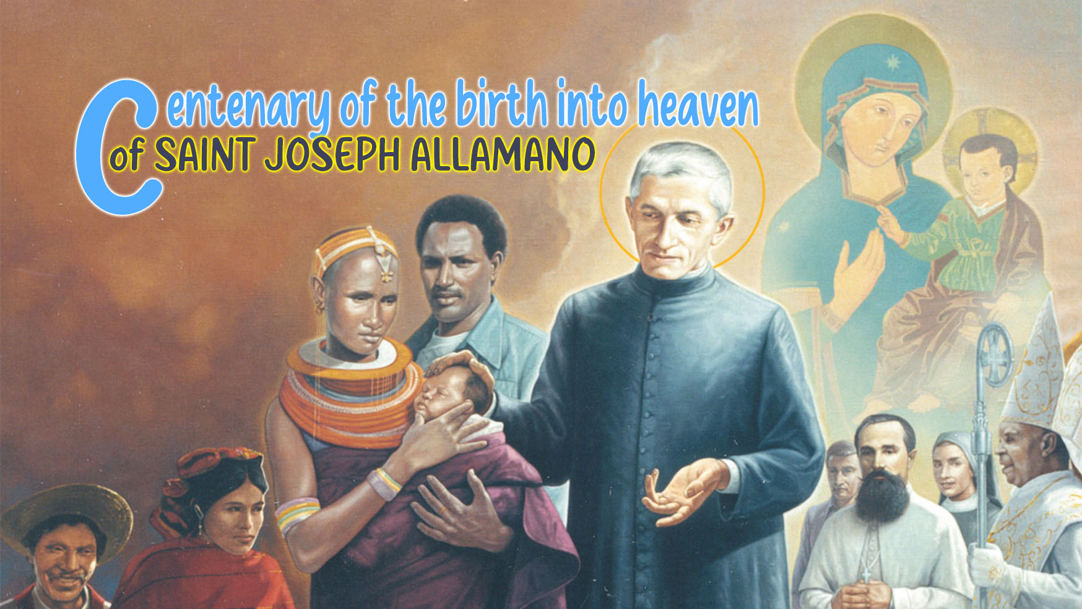

11

Holiness
and the Word of God

We know well how much St. Joseph Allamano loved the Word of God and how courageously he exhorted the missionaries to do the same. “The Bible will be your book!” - he told them. His words sounded prophetic at a time when the Church and the seminaries still considered Sacred Scripture as something reserved for scholars. With great conviction he exhorted us: “Consider the importance of the Sacred Scripture for us and for others!” Everything is there; it is the Word of God, a living and warm word. And he recalled what St. Jerome said: “Never let the Holy Bible fall from your hands, so that sleep may always surprise us with the book in our hands.” The Sacred Scripture! The more you read, the more you study and the more you love it and delight in it. This is a school that never ends. Let us love the Holy Scripture very much, especially the Gospels and the letters of St. Paul. I want you to become fond of the Holy Scripture!
Addressing consecrated persons, the Church writes about the Word of God:
It was the Holy Spirit who ignited the Word of God with new light for the founders and foundresses. Every charism and every Rule springs from it and seeks to be an expression of it. In continuity with founders and foundresses their disciples today are called to take up the Word of God and to cherish it in their hearts so that it may be a lamp for their feet and a light on their path (cf. Ps 118:105). The Holy Spirit will then be able to lead them to the fullness of truth (cf. Jn 16:13).
The Word of God is nourishment for life, for prayer and for the daily journey, the principle which unifies the community in oneness of thought, the inspiration for ongoing renewal and apostolic creativity. […] Within communities and in groups of consecrated men and women, as in the whole Church, a more lively and immediate contact with the Word of God has developed in recent years. It is a path which must continue to be walked down with an ever-greater intensity.

1. The Word
In this reflection we do not understand Sacred Scripture as a simple object of study, or as a mere source of inspiration for preaching or catechesis. We approach it as the “eternal Word” of the Father, the Word of life, God's message to man so that man may know God and encounter him and be converted. St. John writes in his Gospel: “They were yours, and you gave them to me, and they have kept your word. Now they know that everything you have given me is from you; for the words that you gave to me I have given to them, and they have received them and know in truth that I came from you; and they have believed that you sent me.” (Jn 17:6-8).
There is only one great reality: the Word-Person who is Christ Jesus. The words he said are himself. To receive the word is to receive Christ. The book of the Bible is alive like Christ: it still acts today; it has perennial youth. It is alive because it contains the Spirit who gives it the breath of life. St. Gregory: “As the Spirit of life touches the soul of the prophet, so it touches the soul of the reader.”
It is the word of life and therefore generates Christ in us and in others. “My mother and my brothers are those who hear the word of God and put it into practice.” (Lk 8:21). “By his own choice he gave us birth by the word of truth, so that we would become a kind of first fruits of his creatures.” (Jas 1:18).
Word = Dabar: it means what lies at the bottom of things, the truest part. “To speak” in the Bible therefore means making visible the profound nature of things. In fact, God uses the word to create, to guide, to enlighten the human mind. For this reason, his word is always effective and does not go back without causing its effect (Is 31:2).
We, on the other hand, often have a different idea of the term “word”: it is an empty thing, without substance (“words, just words!”). In the Bible, the word is more than an idea or a concept: it is a seed that contains life within itself (Mt 13:19), it produces life. For us Christians, Christ is our “very short word” that contains all the words of Scripture.
Effects of the Word: it gives life, it gives strength, it converts, it opens the way to the truth, it gives wisdom, it arouses union with God, it creates communion and community, it reveals the mystery.

2. The missionary before the Word
The New Testament presents the disciple to us as one who “stays” with Christ: listening, desirous of possessing the living word of God and being possessed by Him. 1 Jn 1:1-5: programmatic text of every disciple-missionary: to see..., to touch..., to proclaim...
A – Encounter with Jesus, the Word of God, at the level of knowledge. To live and love it we need to touch it and know it. St. Jerome: “To ignore Scripture is to ignore Christ.” St. Paul to Timothy: “continue in what you have learned and firmly believed, knowing from whom you learned it. From childhood you have known the sacred writings that are able to instruct you for salvation through faith in Christ Jesus. All scripture is inspired by God and is useful for teaching, for convincing, for correction, and for training in righteousness, so that everyone who belongs to God may be proficient, equipped for every good work.” (2 Tim 3:14-17).
Today more than ever, consecrated persons need to acquire “the intelligence of faith”: to be in harmony with the Spirit; to discern God's will; to scrutinize the signs of the times; to fulfil the vocation of prophet.
B – The intelligence of faith enables us to “be” with Jesus, to live with him and to have a vital, true and authentic experience of him. A disciple is not one who is content with “knowing” but one who falls in love with his Lord and Master: the Word is a proposal of God's love for man. Response to the Word is the beginning of the dialogue of love. Let us remember the episode of Martha and Mary: “Mary sat at the Lord’s feet and listened...” (Lk 10:38-42). To be with the Word is to be with Christ.
C – Existential unity between Word and life: the Word exists to be lived: “Be doers of the word, and not merely hearers who deceive themselves.” (Jas 1:22); “Everyone then who hears these words of mine and acts on them will be like a wise man who built his house on rock.” (Mt 7:24); “There is nothing in the words of God that should not be acted upon; and everything that is said has in itself the need to be put into practice. God's words are decrees.”
D – The Vatican II and the documents of the Church like to present and describe the religious as a “witness”. His apostolate does not consist so much in a series of actions, but rather in sharing Christ, the living word of God. Those who own it, those who live it, can give it. This is the path of the Religious: to listen to the Word, to live it and to give it through his testimony of life.

For personal reflection
Mt 13:18-23; 2 Tim 3:14-4:5
Cf. CIVCSVA, Starting Afresh from Christ 24; VC 94; NMI 39; Verbum Domini
I ask myself:
- Am I convinced that I must become a “living exegete” of the Word?
- Do I know how to go from the word to “The Word”?
- What process do I put in place so that the Word of God becomes in me the “word of life”?

Cf. This I want you to be, ns. 171-174.
CIVCSVA, Starting Afresh from Christ 24.
Hilary of Poitiers, Tract. in Psalmum, 13, 1: PL 9, 295

